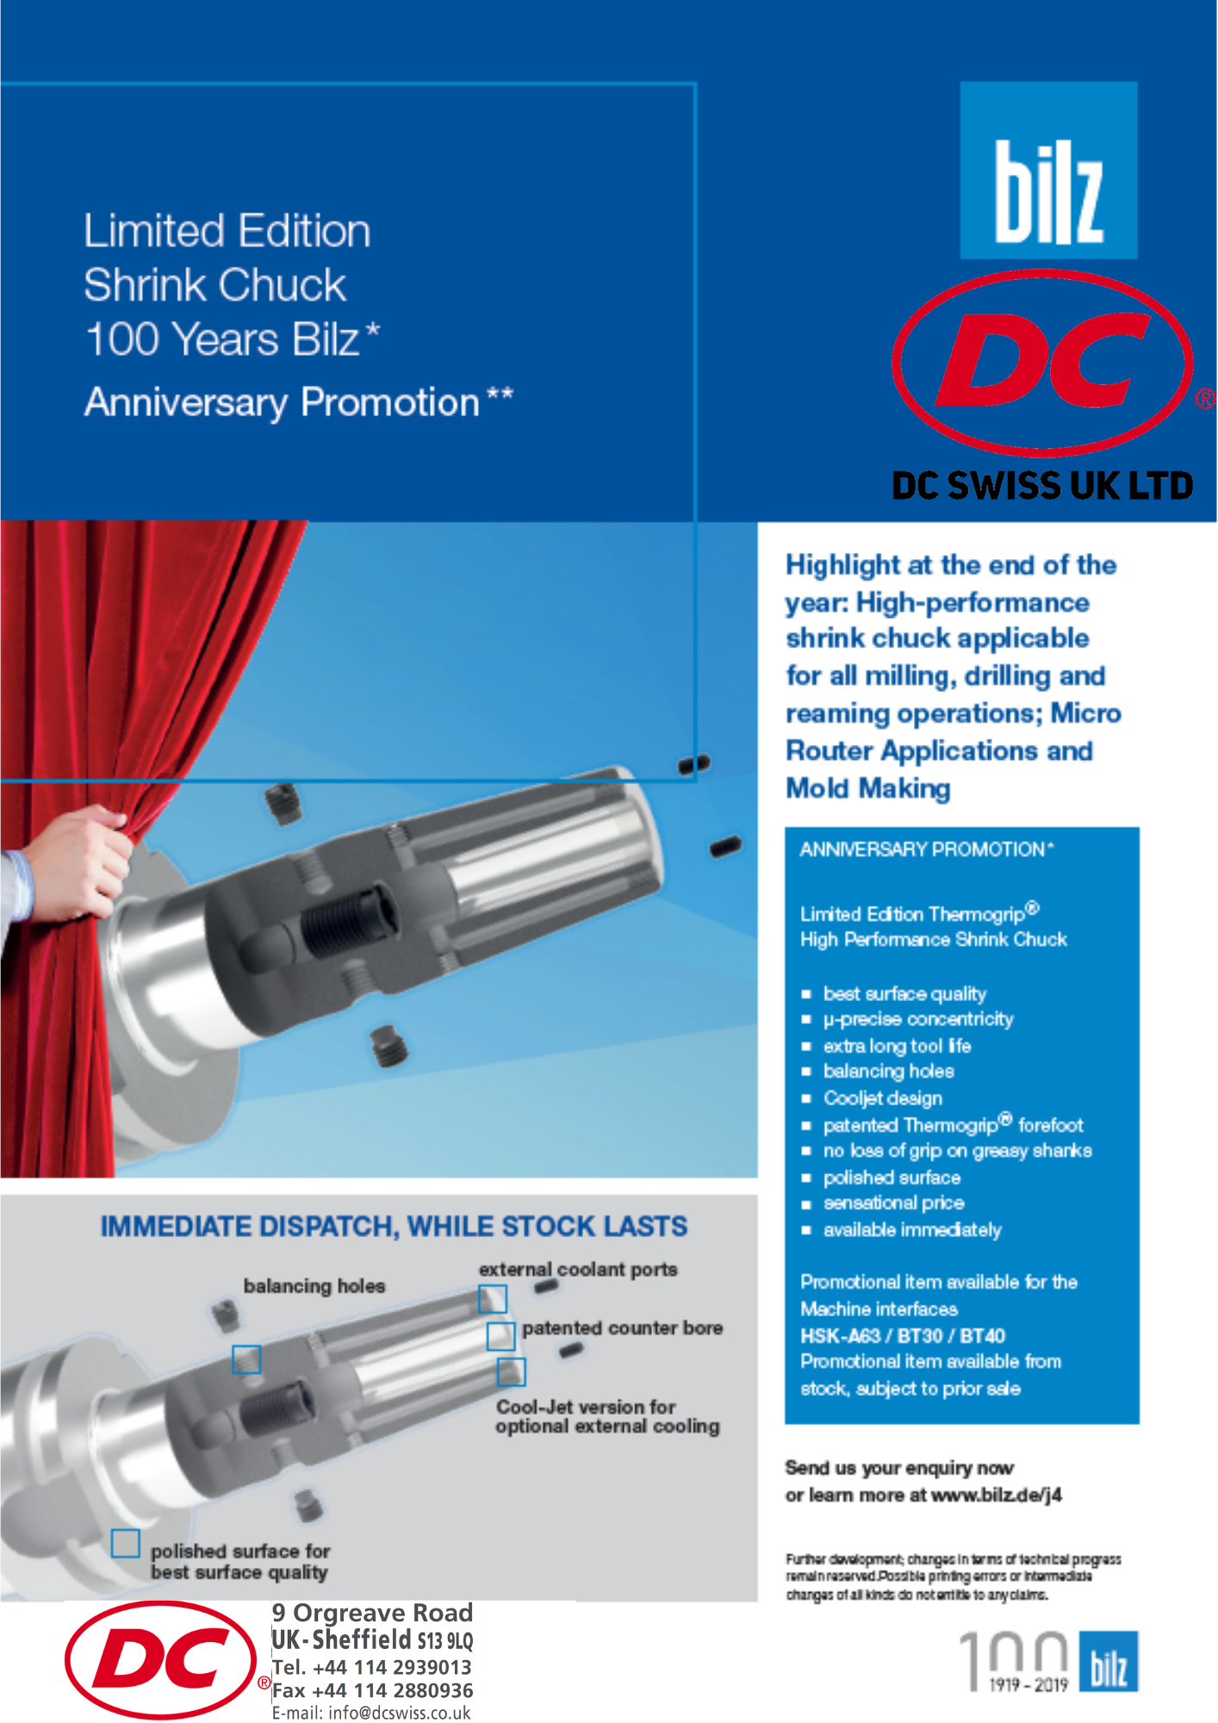

SIMPLY EMAIL ENQUIRIES TO info@dcswiss.co.uk QUOTING 100 YEAR BILZ OFFER

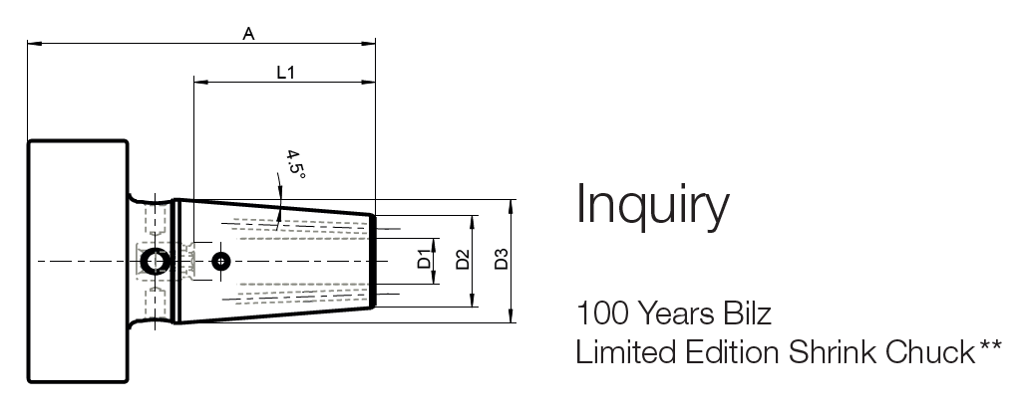

HSK A63 | Designation D1 A | IdentNr. | D2 [mm] | D3 [mm] | L1 max. [mm] | Netprice  £
 | M0600-80-C1-HSKA63-SA | 5151153 | 21 | 27 | 36 | 90.68
 | M0800-80-C1-HSKA63-SA | 5151155 | 21 | 27 | 36 | 90.68
 | M1000-85-C1-HSKA63-SA | 5151164 | 24 | 32 | 42 | 90.68
 | M1200-90-C1-HSKA63-SA | 5151165 | 24 | 32 | 47 | 90.68
 | M1600-95-C1-HSKA63-SA | 5151171 | 27 | 34 | 50 | 90.68
 | M2000-100-C1-HSKA63-SA | 5151177 | 27 | 42 | 52 | 90.68
BT40 | M0600-90-C1-JD40-SA | 5151679 | 21 | 27 | 36 | 74.01
 | M0800-90-C1-JD40-SA | 5151680 | 21 | 27 | 36 | 74.01
 | M1000-90-C1-JD40-SA | 5151682 | 24 | 32 | 42 | 74.01
 | M1200-90-C1-JD40-SA | 5151685 | 24 | 32 | 47 | 74.01
 | M1600-90-C1-JD40-SA | 5151687 | 27 | 34 | 50 | 74.01
 | M2000-90-C1-JD40-SA | 5151688 | 27 | 42 | 52 | 74.01
BT30 | M0600-80-C1-JD30-SA | 5152481 | 21 | 27 | 36 | 64.77
 | M0800-80-C1-JD30-SA | 5152483 | 21 | 27 | 36 | 64.77
 | M1000-80-C1-JD30-SA | 5152484 | 24 | 32 | 42 | 64.77
 | M1200-80-C1-JD30-SA | 5152485 | 24 | 32 | 47 | 64.77
 | M1600-80-C1-JD30-SA | 5152486 | 27 | 34 | 50 | 64.77
 | M2000-90-C1-JD30-SA | 5152487 | 27 | 42 | 52 | 64.77

* Promotion period: from now until 31.12.2019, please note, this promotion can not be combined with other promotions! The prices are current net prices plus VAT, plus transport costs. All prices correspond to the current valid labor and material costs. In case of changes to these costs, we reserve the right to review the offer.
** Valid for Bilz promotional items “Limited Edition”

